Name: _________________________ Date: ___________

**Review**

**8.4, 8.5, 8.6 and 8.8**

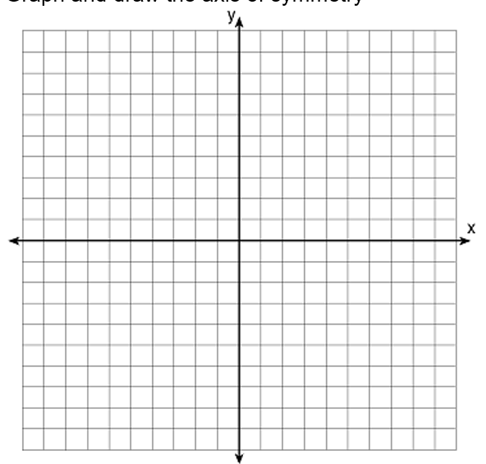1) Graph the following quadratic function: $y=x^{2}+2x-3$

a. Label the axis of symmetry

axis of symmetry:

b. Vertex:

c. Roots:

d. Table of values:

1) Graph the following quadratic function:



a. Label the axis of symmetry



axis of symmetry:

b. Vertex:



c. Roots:



d. Table of values:

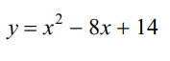**Directions (3 and 4):** Identify the vertex and axis of symmetry. You have to change them into vertex form! (have to use completing the square)

3) 4)

Directions (5 and 6): Identify the vertex.

5) 6)

7) Graph and identify the vertex of: 8) Graph and identify the roots of:

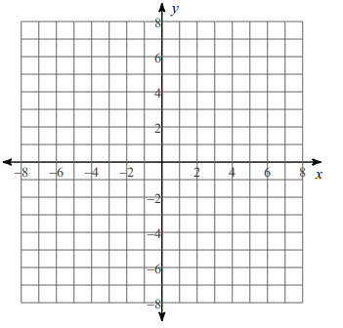 

**Directions (9-10):** Find the value of the discriminant and state the number of real roots. (Make sure it is in standard form first)

9) 10)

**Directions (11-12):** Use the quadratic formula to find the solutions of the quadratic equations. (Make sure they are in standard form first)

11) 12)